**A-1.**

**Laboratory Meters and Power Supply**

**OBJECTIVES:**

After performing this experiment, you will be able to:

1. Read analog meter scales including multiple and complex scales.

2. Operate the power supply at your lab station.

3. Explain the functions of the controls for the multimeter at your lab station. Use it to make a voltage reading.

**READING:**

Floyd, Principles of Electric Circuits, Sections 2-1 through 2-8

Operator’s Manual for Laboratory Multimeter and Power Supply

**MATERIALS NEEDED:**

None

For Further Investigation: Meter calibrator

Application Problem: Eight different colored wires

**SUMMARY OF THEORY:**

***The Power Supply***

Most electronic circuits require a source of regulated direct current (dc) to operate properly. A direct current-regulated power supply is a circuit that provides the energy to allow electronic circuits to function. It does this by transforming a source of input electrical power (generally ac) into dc. Most regulated supplies are designed to maintain a fixed voltage that will stay within certain limits of voltage for normal operation. Voltage adjustment and current limits depend on the particular supply.

The power supply must provide the proper level of dc voltage for a given circuit. Some integrated circuits, for example, can function properly only if the voltage is within a very narrow range. You will normally have to set the voltage to the proper level before you connect a power supply to the test circuit. The power supply at your bench may have more than one output and normally will have a built-in meter to help you set the voltage. Most laboratory power supplies have meters that monitor both voltage and current.

It is important that you make good connections to the power supply output terminals with wire that is sufficient to carry the load current if the output were accidentally shorted together. Clip leads are not recommended because they can produce measurement error due to high contact resistance. In situations where several circuits are operated from the same supply, the best policy is to operate each circuit with an independent set of leads.

***Basic One-Function Meters***

The measurement of various electrical quantities (voltage, current, power, frequency) is basic to determining circuit performance. Many of these electrical quantities are measured with meters. The schematic symbol for a basic, one-function meter is shown in Figure 1. The meter function is shown on the schematic with a letter or symbol. The most basic single function meter is the ammeter, indicated with a letter A on the symbol.

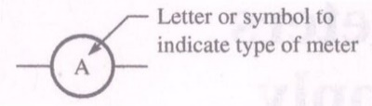

Figure 1. A meter symbol.

The meter indicated is an ammeter.

Ammeters require special care to avoid damage. An ammeter must never be connected across a voltage source. Current measurements are accomplished by selecting the highest range first, then downranging the meter as required for a good measurement. Although digital meters are widely used, many quantities are still indicated with older analog panel meters. These meters begin life as an ammeter but may be converted with circuitry to read almost any physical quantity, including voltage, current, power, or even nonelectrical quantities such as weight, speed, or light. The scales on analog meters may be either linear or nonlinear. There may be several scales on the same meter face. Although they are not as common in new designs, you should be able to read an analog meter accurately.

In reading an analog meter, it is important to know what value to assign to each mark on the meter scale. Start by looking at the primary divisions on either side of the needle. A primary division is one with a number. Secondary divisions are unnumbered marks between the primary divisions. For example, the meter in Figure 2 has primary divisions of 0, 5, 10, 15, and 20 mA. The needle is between the 5 mA primary division and the 10 mA primary mark. Next, determine what each secondary mark is worth. Since there are nine marks (10 spaces) between 5 and 10, each mark is worth 0.5 mA. The reading is interpreted as 9.2 mA.

Sometimes more than one scale is present; in this case, it is called a multiple scale. For example, the top scale in Figure 3 has a full-scale value of 10 V. This scale should be read if the 10 V range is selected. For this scale, the primary divisions are 2 V and the secondary divisions are 0.5 V. If this range is selected, the meter reading is interpreted as 8.5 V.

***The Multimeter***

The digital multimeter (DMM) and analog volt-ohm-milliammeter (VOM) are multipurpose measuring instruments that combine the characteristics of a dc and ac voltmeter, dc and ac ammeter, and an ohmmeter in one instrument. Examples of a portable VOM and DMM are shown in Figure 4. The DMM indicates the measured quantity as a digital number, avoiding the necessity to interpret the scales, as is required on analog instruments. It is also more accurate, smaller, less expensive, easier to use, and more versatile than a VOM. Although the DMM has replaced the VOM as the instrument of choice, there are a few advantages for the VOM and some are still in use. It is generally less susceptible to interference and often has a higher frequency response than a DMM. In experimental work, it is generally assumed that you are using a DMM, but you can use a VOM if you choose.

|  |  |
| --- | --- |
| Z:\임시 인터넷 파일\Content.Word\figure2_.jpg  Figure 2 | Z:\임시 인터넷 파일\Content.Word\figure3.jpg  Figure 3 |

Because the multimeter is a multipurpose instrument, it is necessary to determine which controls select the desired function. In addition, current measurements (and often high-range voltage measurements) usually require a separate set of lead connections to the meter. Most DMMs can select the proper range scale automatically (this is called autoranging). An autoranging meter may also have an AUTO/HOLD switch, which allows the meter to either operate in the autoranging mode or to hold the last range setting. For manual ranging meters, you need to select the function and the range before connecting the meter to the circuit you are testing. When the approximate voltage or current is not known, always start on the highest range to avoid instrument overload and possible damage. Change to a lower range as necessary to increase the precision. On VOMs, the range selected should give a reading in the upper portion of the scale.

The voltmeter function of a DMM can measure either ac or dc volts. The dc voltage function is useful to measure the dc voltage difference between two points. If the meter’s red lead is touching a more positive point than the meter’s black lead, the reading on the meter will be positive; if the black lead is on the more positive point, the reading will be negative. Analog meters must be connected with the correct polarity, or the pointer will attempt to move backward, possibly damaging the movement.

|  |  |
| --- | --- |
| **figure4_a**   1. **VOM** | **Z:\임시 인터넷 파일\Content.Word\figure4_b.jpg**   1. **DMM**   **(Courtesy of Triplett Co.)** |

**Figure 4**

The ac voltage function is designed to measure low-frequency sinusoidal waveforms. The reading on a meter is calibrated to read the rms (root-mean-square) value of a sinusoidal waveform. Frequency is the number of cycles per second, measured in hertz, for a waveform. All DMMs and VOMs are limited to some specified frequency range. The meter reading will be inaccurate if you attempt to measure waveforms outside the meter’s specified frequency range. A typical DMM is not accurate on the ac scale below about 45 Hz or above about 1 kHz, although this range can be considerably better in some cases, depending on the internal circuitry. A VOM generally is good to 100 kHz or so. Before measuring any frequency above 1 kHz, you should check the specifications of your meter.

The ohms function (used for resistance measurements) is used only in circuits that are not powered. An ohmmeter works by inserting a small test voltage into a circuit and measuring the resulting current. Consequently, if any voltage is present, the reading will be in error. The meter will show the resistance of all possible paths between the probes. If you want to know the resistance of a single component, it is necessary to isolate that component from the remainder of the circuit by disconnecting one end. Do not assume a power supply that is turned off is an open path! In addition, your own body resistance can affect the reading if you are holding the conducting portion of both probes in your fingers. This procedure should be avoided, particularly with high resistances. Examples of how to connect an autoranging DMM for measurement of voltage and resistance are shown in Figure 5.

The ammeter function of a DMM can measure either ac or dc current. As in the case of basic ammeters, when a DMM or VOM is used to measure current, it is important to insert the meter in series with the source and a load. If it is accidentally placed in parallel with a voltage source, very high current will occur, causing a fuse to blow or damage to the meter. Generally, before you can measure current, you need to reposition the test leads to a special socket (or sockets) on the meter designated for current measurements. Start on a high range and downrange the meter as necessary.

VOMs contain meters that can be used for more than one function (voltage, resistance, current). The scales on a VOM are called complex scales because they can indicate various functions. To read a complex scale, the user chooses the appropriate scale based on the function and the range selected. Figure 6 shows a complex scale from a VOM. Notice that the top scale is used for measuring resistance and is nonlinear.

If the function selected is resistance, then the top scale is selected. Notice that the secondary divisions change values across the scale. To determine the reading, the primary divisions on each side of the pointer are noted as before. The secondary divisions can then be assigned values by counting the number of secondary divisions in between the primary divisions. The reading (17.5 in this case) is multiplied by the setting of the range switch.

|  |  |
| --- | --- |
| **Z:\임시 인터넷 파일\Content.Word\figure5_a.jpg**   1. **DC voltage measurement** | **figure5_b**   1. **Resistance measurement** |

**Figure 5**

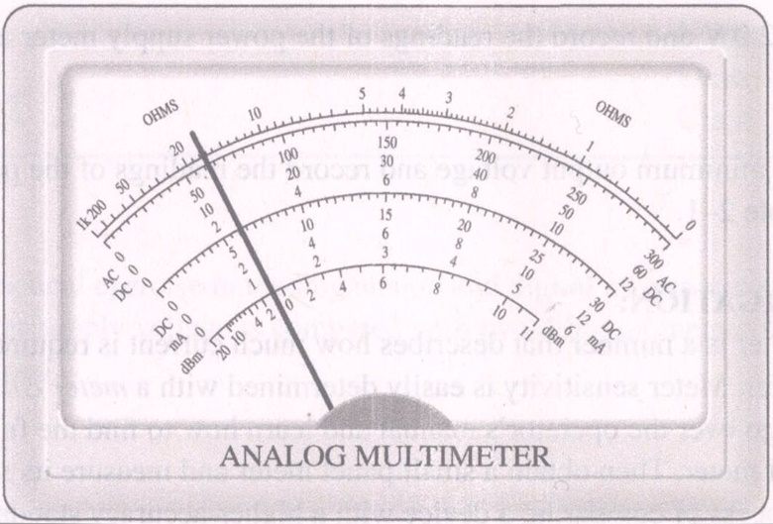

Figure 6

**PROCEDURE:**

1. Observe the meters shown in Figure 7(a) and (b) of the report. These are linear meters with one range. Determine the value of the primary and secondary divisions for each meter. Then determine the meter reading. Record your observations in the space provided in the report.

2. The meter shown in Figure 8 of the report is a VOM scale. Answer the questions in the report for this meter.

3. Look at the meter on the power supply at your lab station. Some power supplies have analog meters that monitor either voltage or current. There may be more than one range or several supplies built into the same chassis, so the meter may have multiple or complex scales. Review the meter and meter controls and answer the questions in the report about your power supply meter.

4. Review the controls for the power supply at your lab station. The operator’s manual is a good resource if you are not sure of the purpose of a control. In the space provided in the report, describe the features of your supply (multiple outputs, current limiting, tracking, etc.).

5. In this step, you will set the power supply for a specific voltage and measure that voltage with your laboratory meter. Review the operator’s manual for the DMM (or VOM) at your lab station. Review each control on the meter. Then select +dc and volts on the DMM. If your DMM is not autoranging, select a range that will measure +5.0 V dc. The best choice is a range that is the smallest range larger than +5.0 V. Connect the test leads together and verify that the reading is zero. (Note: A digital meter may have a small digit in the least significant place.)

6. Turn on the power supply at your station and use the meter on the supply to set the output to +5.0 V. Then use the DMM to confirm that the setting is correct. Record the readings of the power supply meter and the DMM in Table 1.

7. Set the output to +12.0 V and record the readings of the power supply meter and the DMM in Table 1.

8. Set the supply to the minimum output voltage and record the readings of the power supply meter and the DMM in Table 1.

**FOR FURTHER INVESTIGATION:**

The sensitivity of a panel meter is a number that describes how much current is required to obtain full- scale deflection from the meter. Meter sensitivity is easily determined with a meter calibrator. If you have a meter calibrator available, go over the operator’s manual and learn how to find the full-scale current through an inexpensive panel meter. Then obtain a small panel meter and measure its sensitivity.

Calibration is the process of comparing a device with a higher-accuracy standard and then adjusting it or recording the difference. Set the meter calibrator for 25%, 50%, and 75% of the full-scale current. Record the difference between the reading on the calibrator and the reading on the meter. Graph the meter current versus the calibrator current on Plot of your report. This graph is called a calibration curve for the meter.

**APPLICATION PROBLEM:**

A continuity tester is an instrument used to determine if there is a low-resistance path between two points. An ohmmeter can be used as a continuity tester to determine if there is a path for current between conductors. If the ohmmeter reads nearly $0 Ω$, the conductors are connected: if no reading is obtained, the conductors are open. Some meters have a built in audio signal to indicate when there is continuity.

Obtain eight different-colored wires. Have a lab partner connect the ends of random pairs of wires so that you have four pairs of wires. Tape the ends so they are concealed. Using your ohmmeter as a continuity tester, design a test procedure that determines which pairs are connected together in the fewest number of steps. Summarize your procedure in the report.

|  |  |
| --- | --- |
| **Report for**  **Experiment A-1** | **Name**  **Date**  **Class** |

**ABSTRACT:**

This experiment is a practical exercise in reading analog and digital meters and operating a laboratory power supply. The power supply voltage is compared with two different meters. Features and controls of the power supply are noted.

**DATA:**

***Step 1:***

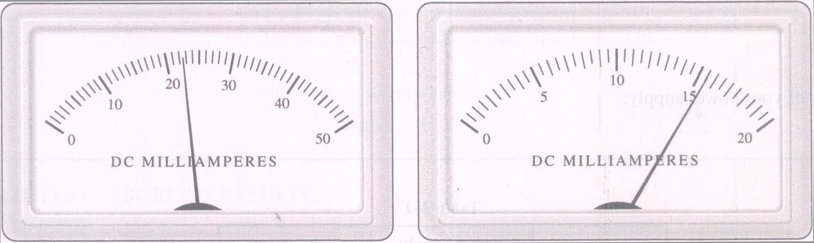

**(a)**  **(b)**

Figure 7

**Meter Readings:**

**Figure 7(a) Figure 7(b)**

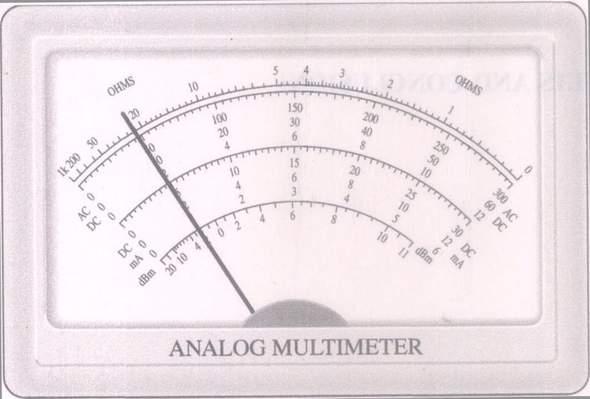

***Step 2:***

Figure 8

For the meter in Figure 8, assume the OHMS function is selected and the range selected is $×1K$ ohms. What does the meter indicate for a resistance?

What is the meter reading if the range selected is the 12 V DC range?

What is the meter reading if the range selected is the 30 V AC range? (You will need to move the decimal point).

***Step 3:***

Is the meter on your power supply used for more than one function?

If so, what determines which function is monitored?

Does it have multiple scales?

Does it have complex scales?

What is the smallest primary voltage division?

What is the smallest secondary voltage division?

***Step 4:***

Features of your power supply:

**Table 1**

|  |  |  |
| --- | --- | --- |
| Step Number | Power Supply  Meter Reading | Lab Station  Meter Reading |
| 6 |  |  |
| 7 |  |  |
| 8 |  |  |

**RESULTS AND CONCLUSION:**

**FURTHER INVESTIGATION RESULTS:**

|  |  |  |  |  |  |  |  |  |  |
| --- | --- | --- | --- | --- | --- | --- | --- | --- | --- |
|  |  |  |  |  |  |  |  |  |  |
|  |  |  |  |  |  |  |  |  |  |
|  |  |  |  |  |  |  |  |  |  |
|  |  |  |  |  |  |  |  |  |  |
|  |  |  |  |  |  |  |  |  |  |
|  |  |  |  |  |  |  |  |  |  |
|  |  |  |  |  |  |  |  |  |  |
|  |  |  |  |  |  |  |  |  |  |
|  |  |  |  |  |  |  |  |  |  |
|  |  |  |  |  |  |  |  |  |  |
|  |  |  |  |  |  |  |  |  |  |

Meter readingot 1ator currentM RESULTS:Thi

Calibrator current

**Plot 1**

**EVALUATION AND REVIEW QUESTIONS:**

1. Compare the precision of the power supply voltmeter with the DMM or VOM at your lab station. Does one meter have an advantage for measuring 5.0 V? Explain your answer.

2. What is meant by an autoranging meter? What type is at your lab station?

3. What is the difference between a multiple scale and a complex scale?

4. What is the difference between a linear scale and a nonlinear scale?

5. Assume a scale has four secondary marks between the primary marks numbered 3.0 and 4.0. If the pointer is on the first secondary mark, what is the reading on the meter?

6. What special precaution is necessary for measuring current with an ammeter?